Name: Arpit Mahalle
Screenshots of react assignment 3 (Day 12)

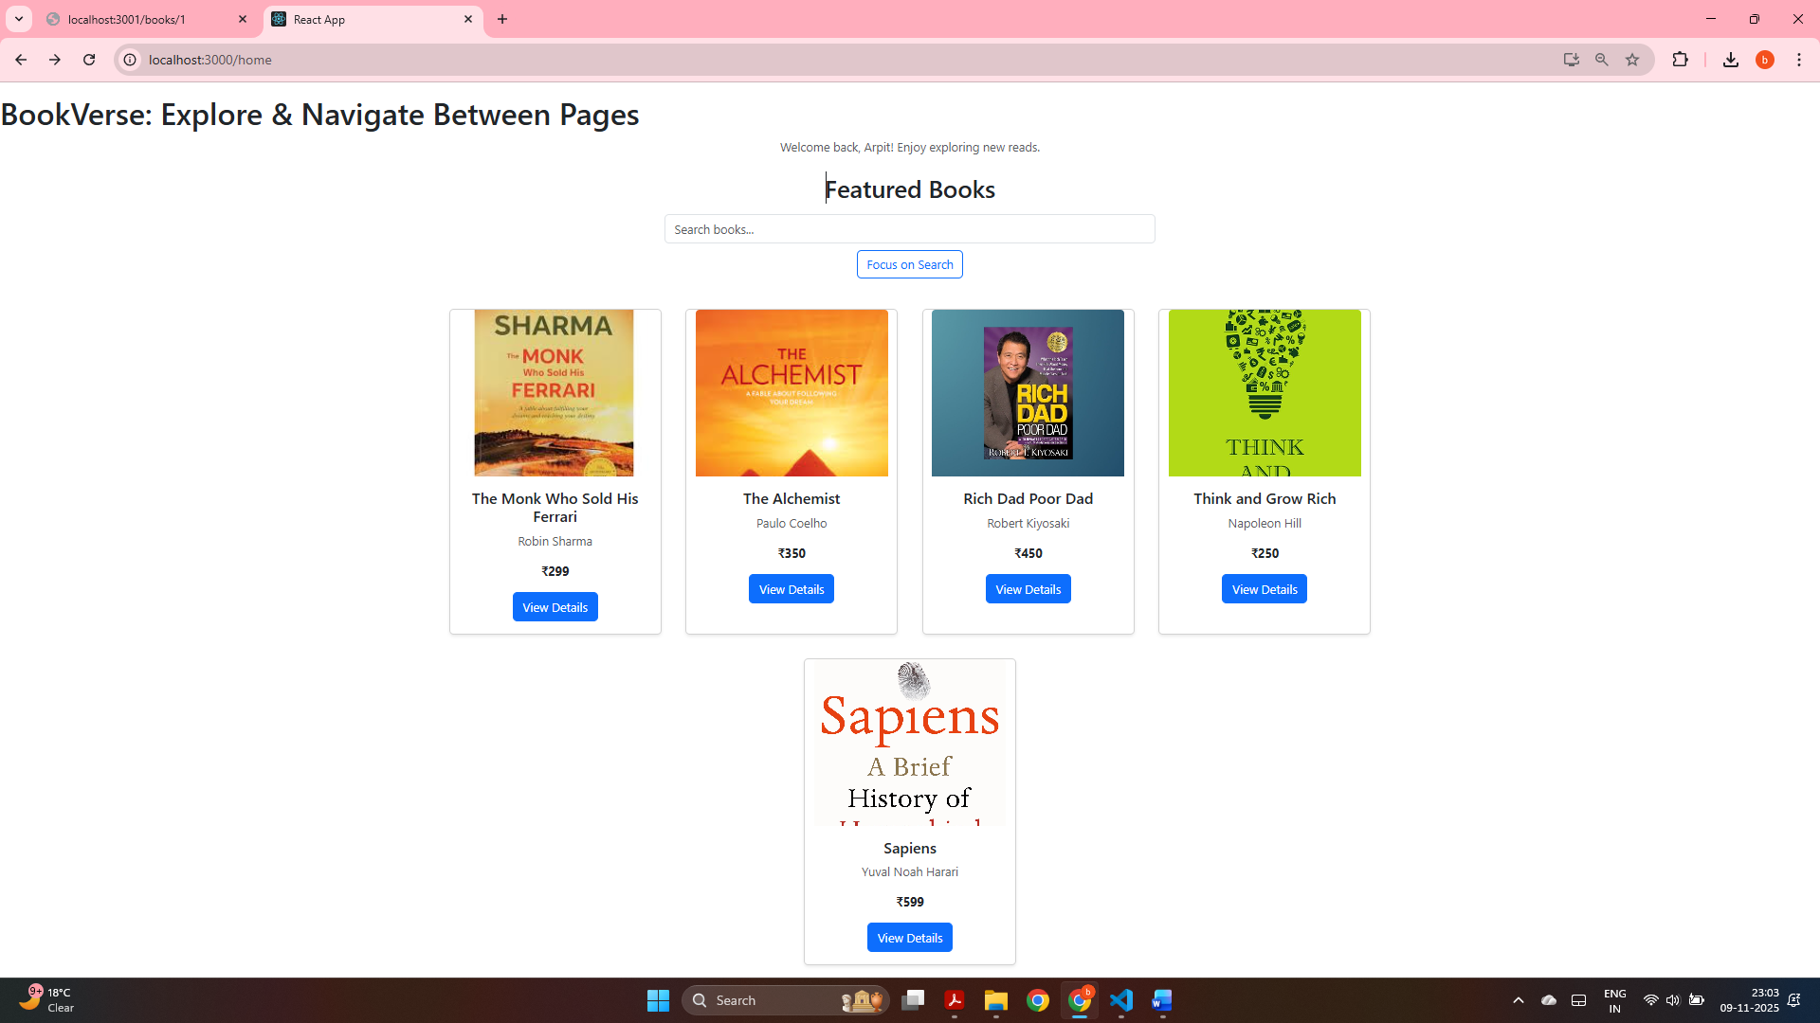
Home page displaying all featured books fetched from the JSON Server with proper images and details.

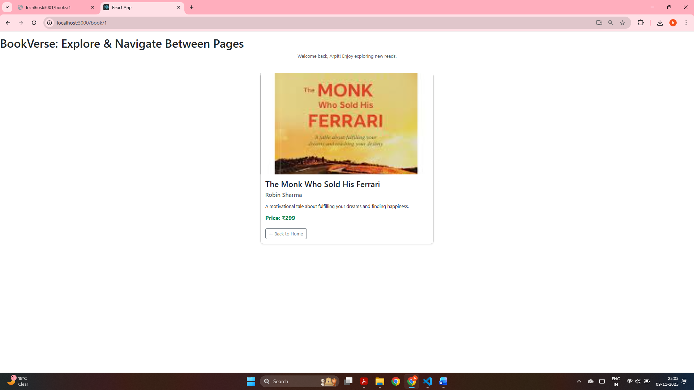
Book Details page showing complete information of “The Monk Who Sold His Ferrari” using React Router dynamic route /book/1.

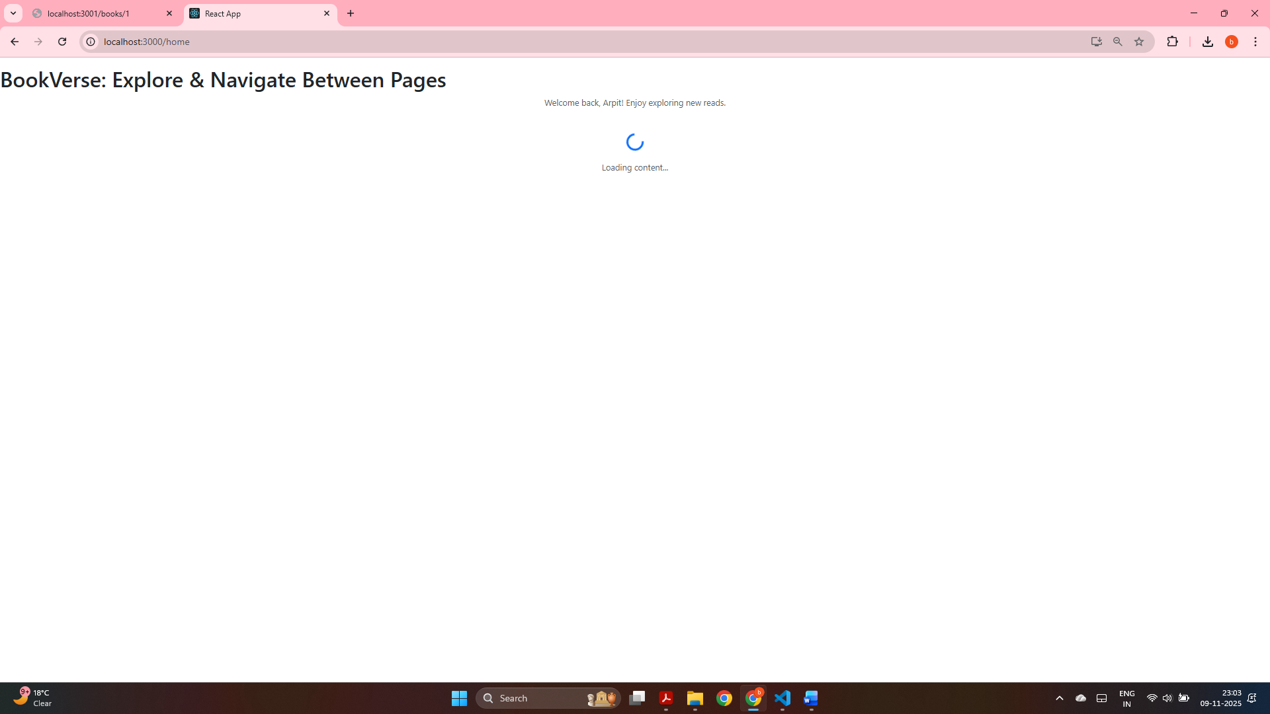
Loading spinner displayed while data is being fetched from the backend during page navigation.
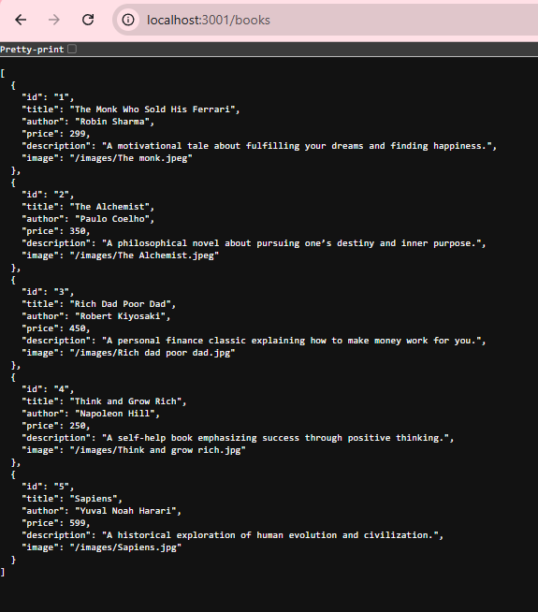
Backend endpoint http://localhost:3001/books correctly returning book details from the JSON Server.

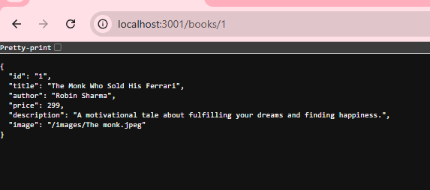
Backend endpoint http://localhost:3001/books/1 correctly returning book details for ID 1 from the JSON Server.

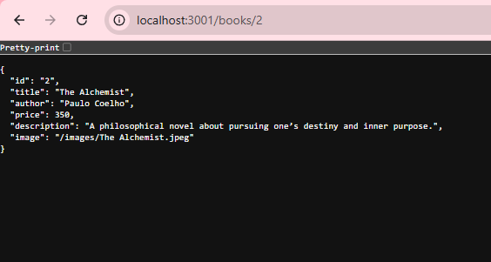
Backend endpoint http://localhost:3001/books/2 correctly returning book details for ID 2 from the JSON Server.

